5.a

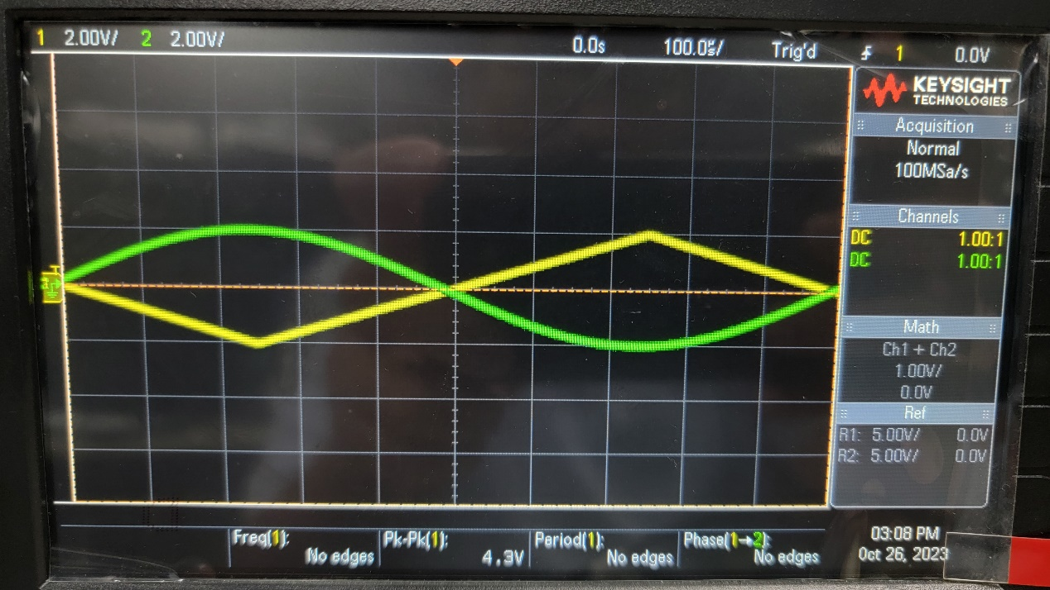

Vertical Scale CH1 = 2.00 V/Div

Vertical Scale CH2 = 2.00 V/Div

Horizontal Scale = 100 µs/Div

Status = Run

Trigger Setting:

▼→Trigger Point = Center = 0.00 s

Source = CH1

Slope at Trigger = ↑

Coupling = DC

Mode = Normal

Vertical Scale CH1 = 2.00 V/Div

Vertical Scale CH2 = 2.00 V/Div

Status = Run

5.b

Vertical Scale CH1 = 2.00 V/Div

Vertical Scale CH2 = 2.00 V/Div

Horizontal Scale = 200 µs/Div

Status = Stop

Trigger Setting:

▼→Trigger Point = Center = 0.00 s

Source = CH1

Slope at Trigger = ↑

Coupling = DC

Mode = Normal

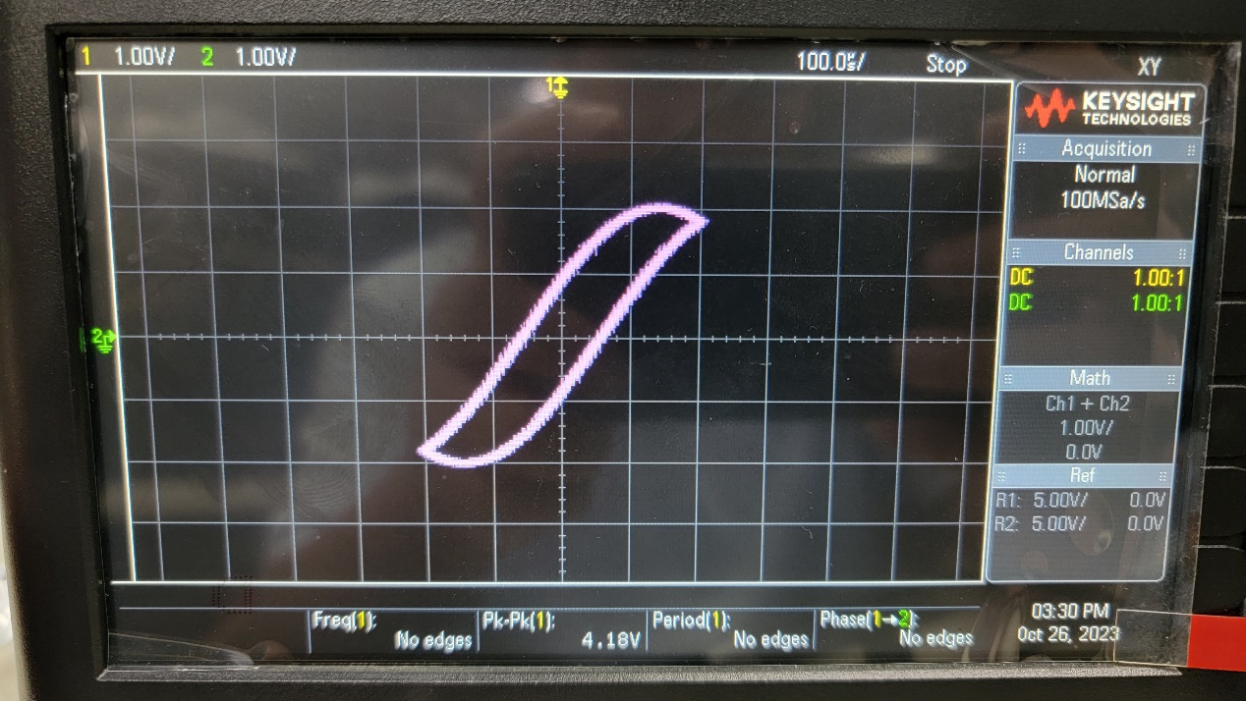

Vertical Scale CH1 = 1.00 V/Div

Vertical Scale CH2 = 1.00 V/Div

Status = Stop

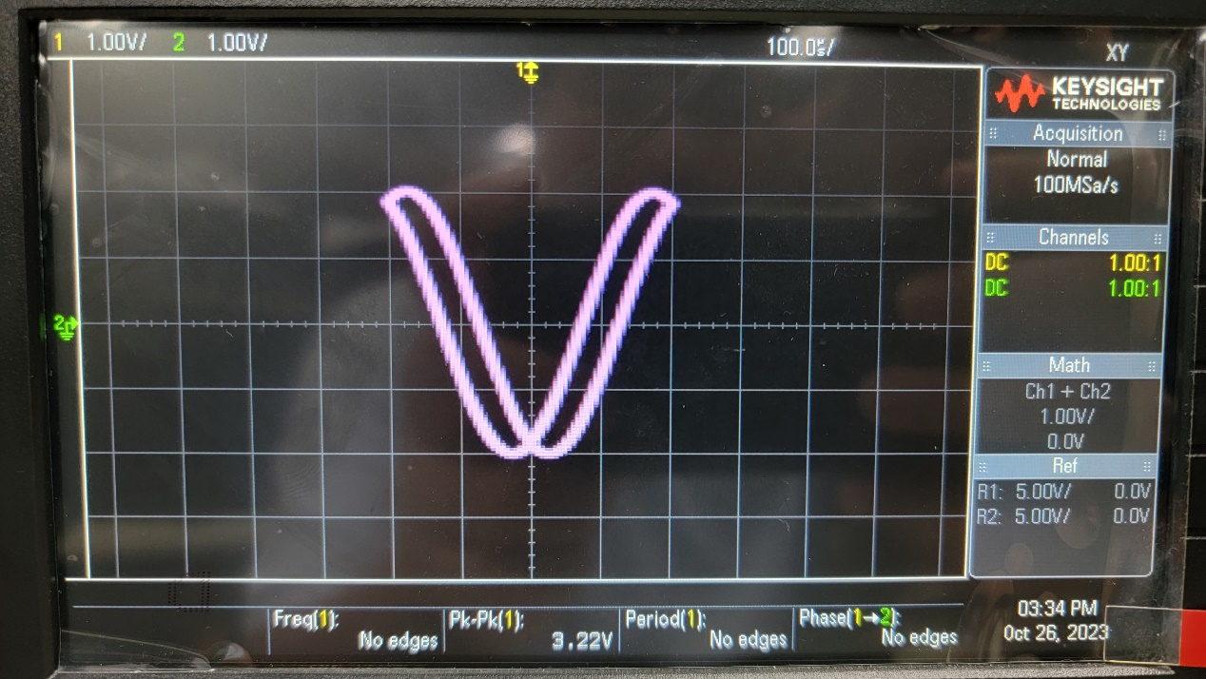

Vertical Scale CH1 = 1.00 V/Div

Vertical Scale CH2 = 1.00 V/Div

Status = Stop

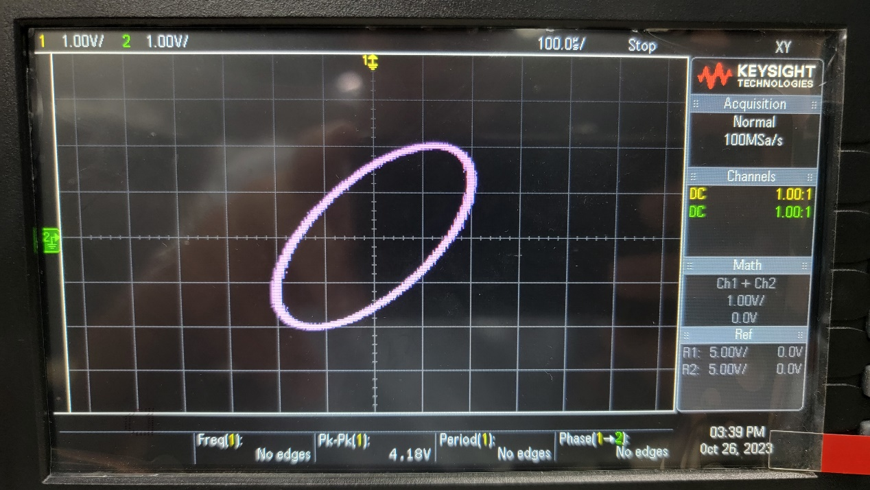

Vertical Scale CH1 = 1.00 V/Div

Vertical Scale CH2 = 1.00 V/Div

Status = Stop

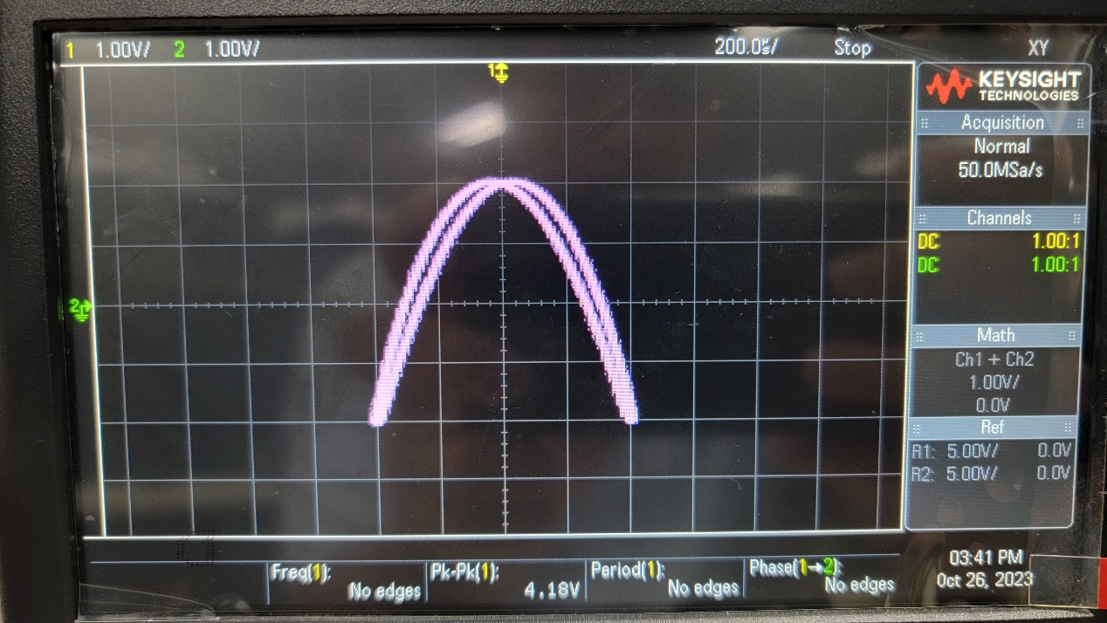

Vertical Scale CH1 = 1.00 V/Div

Vertical Scale CH2 = 1.00 V/Div

Status = Stop

5.c

A1 = 2.00 Vpp

A2 = 2.00 Vpp

f1 = 1000 Hz

f2 = 1000 Hz

θ = 0∘

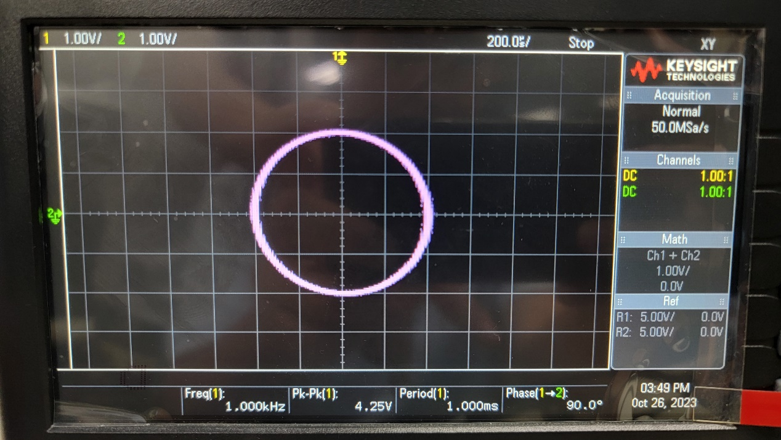

A1 = 2.00 Vpp

A2 = 2.00 Vpp

f1 = 1000 Hz

f2 = 1000 Hz

θ = 90∘

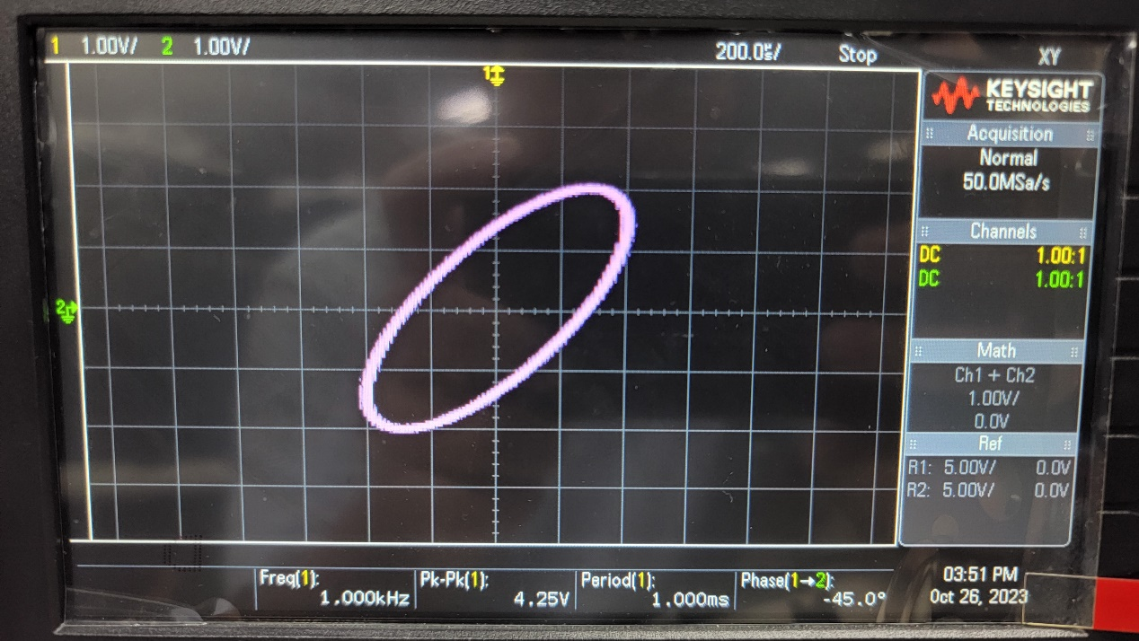

A1 = 2.00 Vpp

A2 = 2.00 Vpp

f1 = 1000 Hz

f2 = 1000 Hz

θ = -45∘

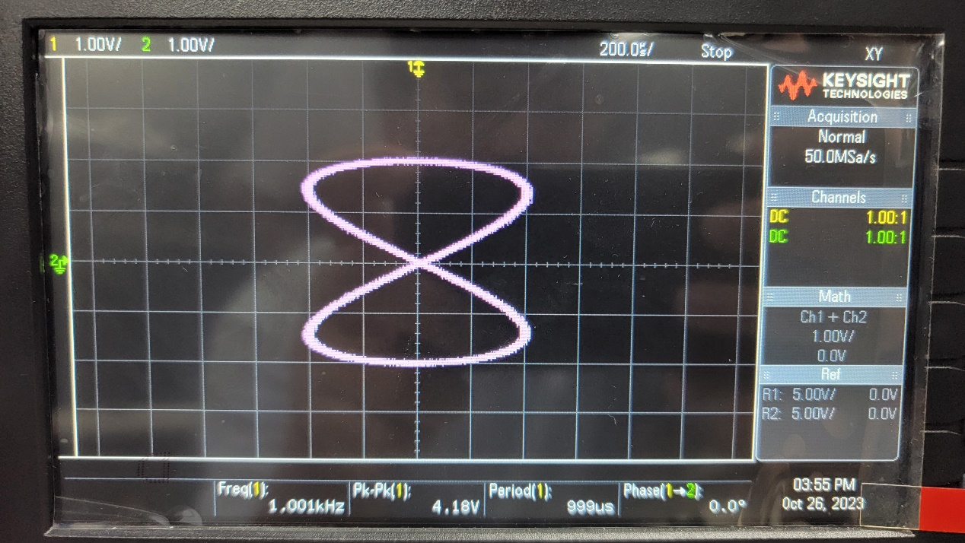

A1 = 2.00 Vpp

A2 = 2.00 Vpp

f1 = 1000 Hz

f2 = 500 Hz

θ = 0∘